**CAPACITOR – REACT JS APP – One web code base for all platforms**

**Architecture –**

CapacitorJS

React JS

Typescript

TailwindCSS

Axios

Redux toolkit

Platforms – Web, Android and iOS

CICD – Github, App Flow, WebHooks

**App Setup**

//Steps to initialize a capacitor app

npx create-react-app capproject --template typescript

//Install capacitor packages

cd capproject && npm install @capacitor/core @capacitor/cli

//initialize capacitor configuration

npx cap init

/*This will prompt you to enter your app name (e.g., My Capacitor React App) and app identifier (e.g., com.example.myapp). Make sure the webDir in the capacitor.config.json is set to build because React's production build files are placed in the build directory.*/

//Install capacitor IOS and Android packages

npm install @capacitor/ios && npm install @capacitor/android

//Add iOS and Android platforms – web is provided by default

npx cap add ios && npx cap add android

Axios setup for API Integration

npm install axios

Redux setup

npm install redux react-redux @reduxjs/toolkit

mkdir src/store && touch src/store/index.ts

src/store/index.ts

// src/store/index.ts

import { configureStore } from '@reduxjs/toolkit'; const store = configureStore({ reducer: { // Add your reducers here }, }); export type RootState = ReturnType<typeof store.getState>; export type AppDispatch = typeof store.dispatch; export default store;

//Update App.js to wrap with store

import React from "react";

import ReactDOM from "react-dom/client";

import "./index.css";

import App from "./App";

import reportWebVitals from "./reportWebVitals";

import { Provider } from "react-redux";

import store from "./store";

const root = ReactDOM.createRoot(

document.getElementById("root") as HTMLElement,

);

root.render(

<Provider store={store}>

<App />

</Provider>,

);

reportWebVitals();

**tailwindcss install – create config files too**

npm install -D tailwindcss postcss autoprefixer

npx tailwindcss init -p

//update tailwind.config.js to consider all the reactjs files

module.exports = {

content: ["./src/**/*.{js,jsx,ts,tsx}"],

theme: {

extend: {},

},

plugins: [],

};

//update postcss.config.js

module.exports = { plugins: { tailwindcss: {}, autoprefixer: {}, }, };

//import tailwind into src/index.css file

@tailwind base;

@tailwind components;

@tailwind utilities;

**// add VS Code extensions –**

Tailwind CSS IntelliSense

PostCSS Intellisense and Highlighting

Ionic

npm install eslint-plugin-tailwindcss --save-dev

//create .eslintrc

{

"extends": ["plugin:tailwindcss/recommended"]

}

**Create build directory for reactjs assets**

Npm run build //creates deployable app with index.html

Npm start

// runs the app on browser

**Sync Capacitor with the Web Project**

npx cap sync

//adds build files to ios and android platforms

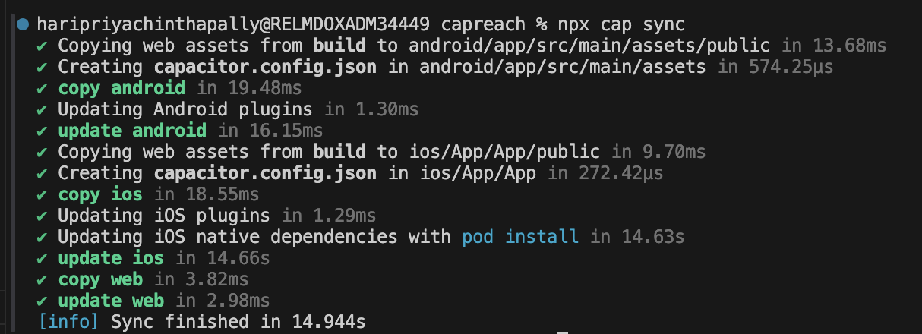

**Project Folder Structure**

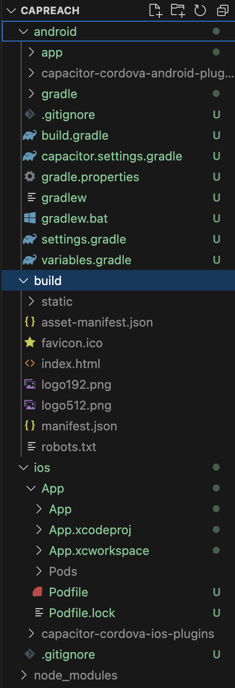

After running npm run build, the build directory contains the following:

* index.html file: The main entry point for your React app.
* static directory: Contains JavaScript, CSS, and other assets required by the app.

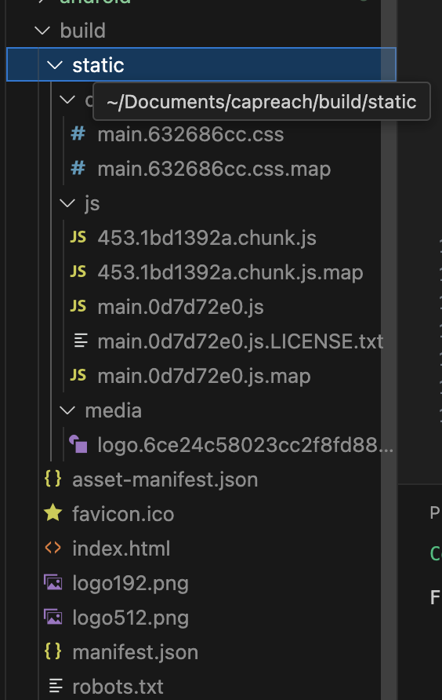

**Run the App on all platforms**

**Web**

**Npm start // localhost 3000 port**

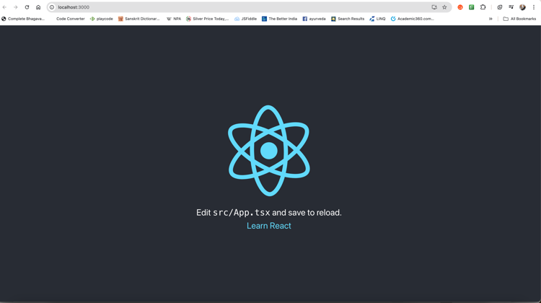

**IOS (Make sure xcode and at least one simulator are installed)**

**npx cap open ios // Opens xcode. Run using Xcode**

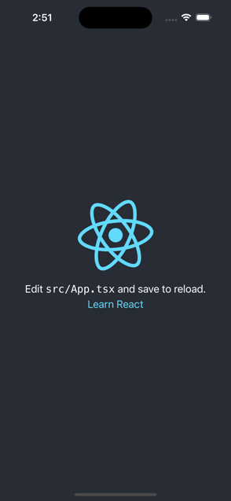

**Android (Make sure Android Studio and at least one emulator are installed)**

**npx cap open android // Opens android studio. Click Run**

**IONIC AppFlow**

**Integrate Ionic Appflow for Deployments and CI/CD**

**Create AppFlow account using Github credentials**

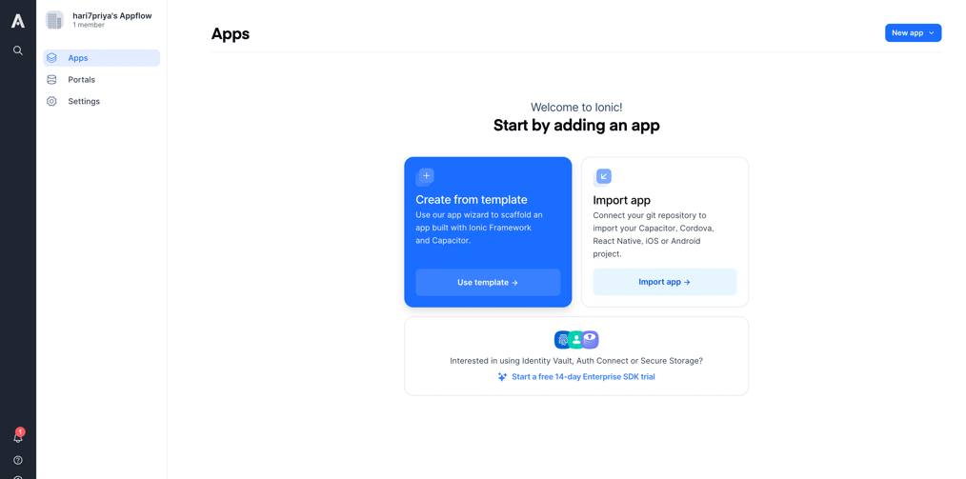

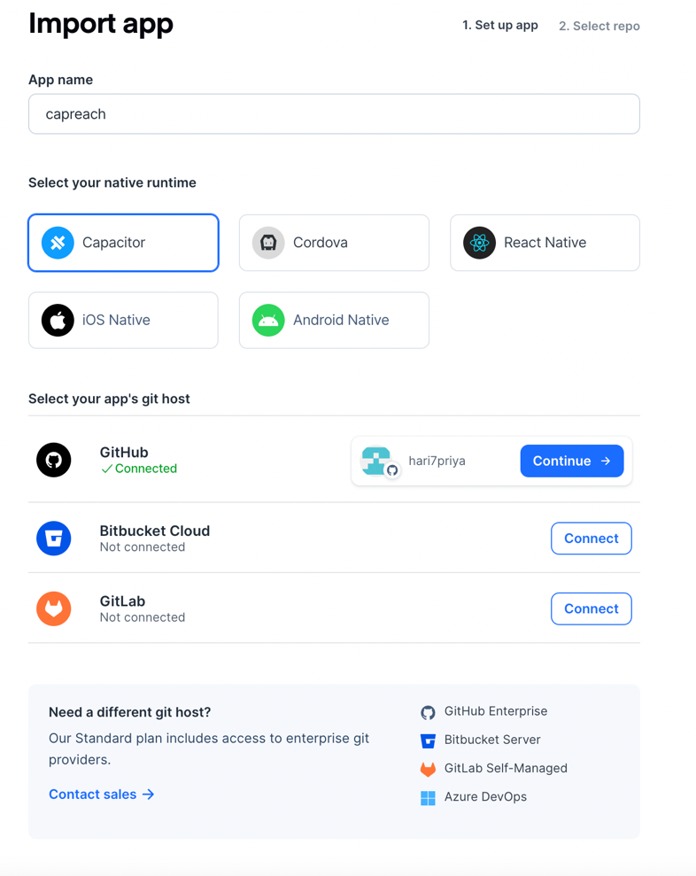

generate a build from the available commits 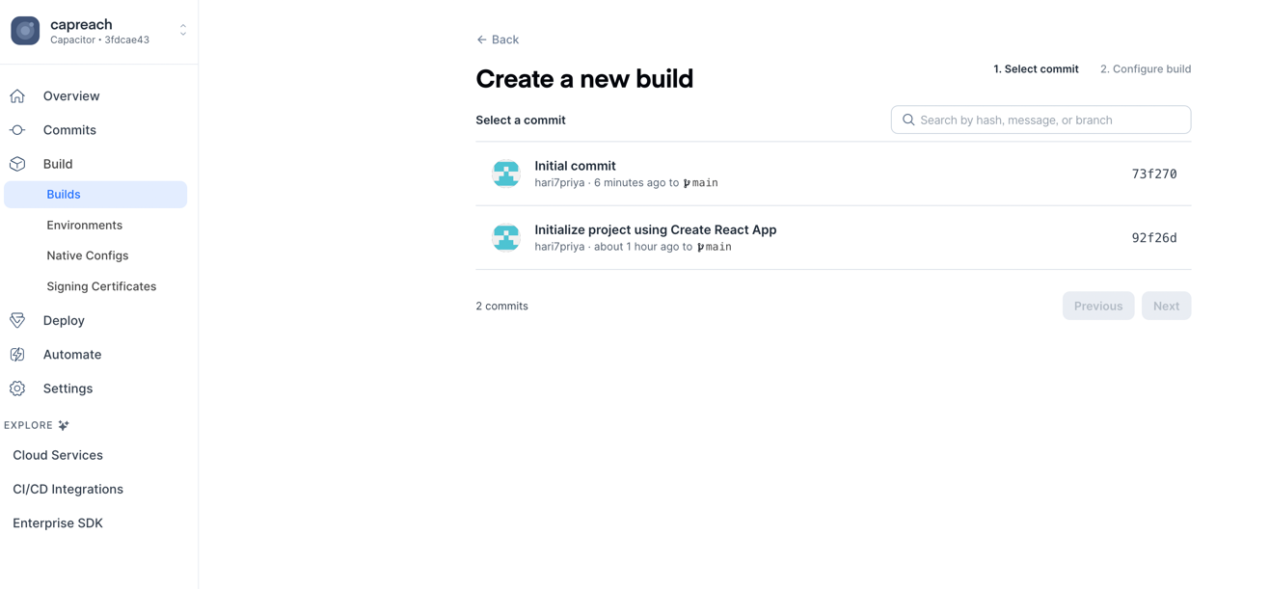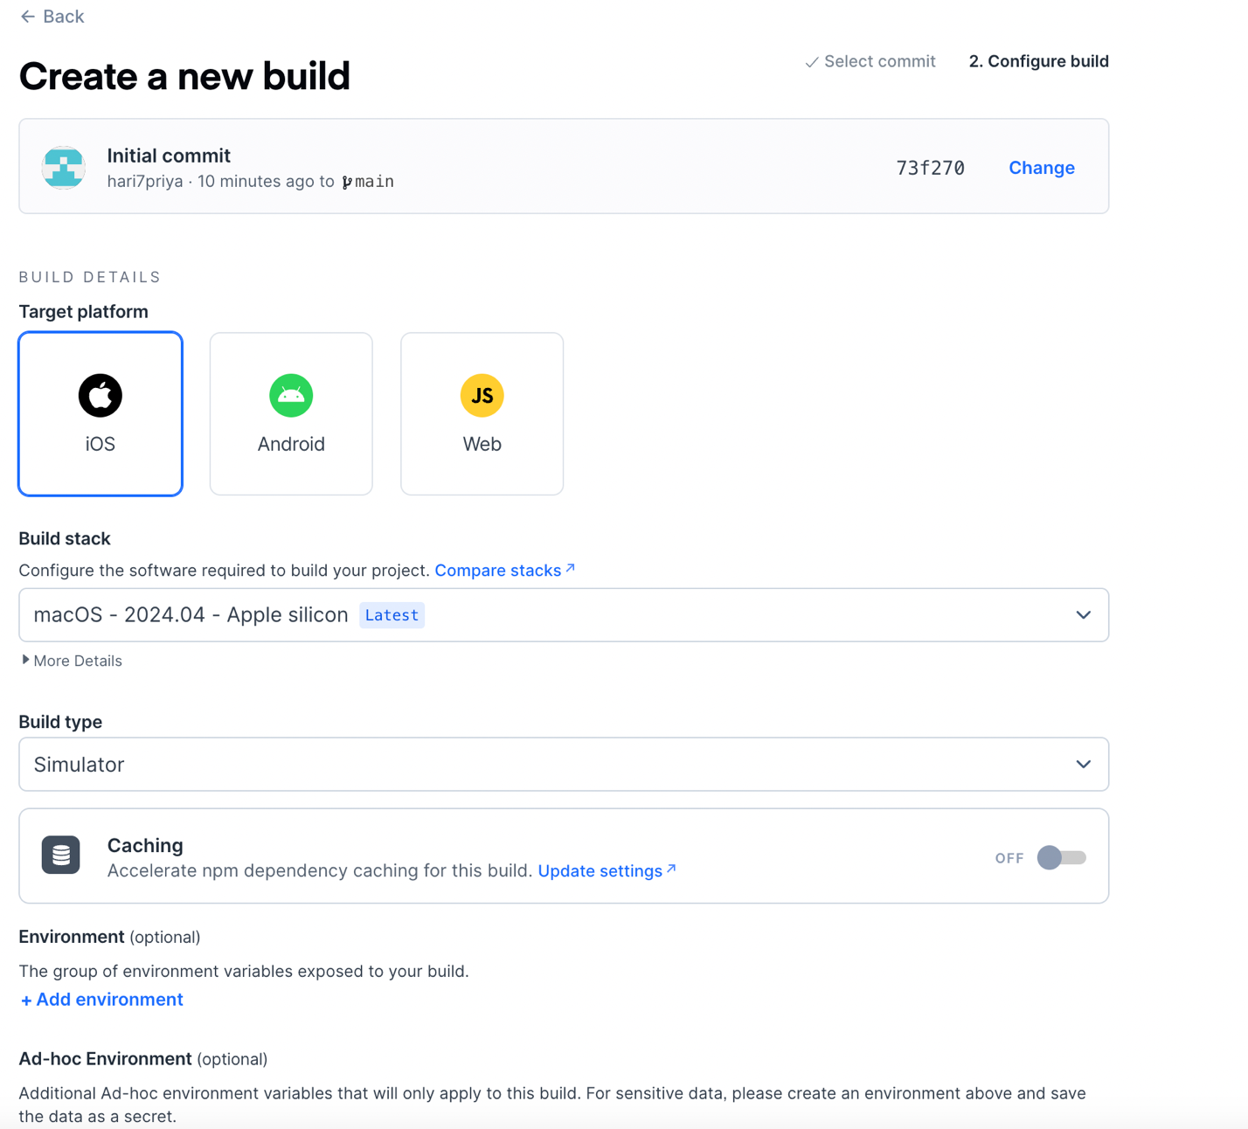

IOS Build

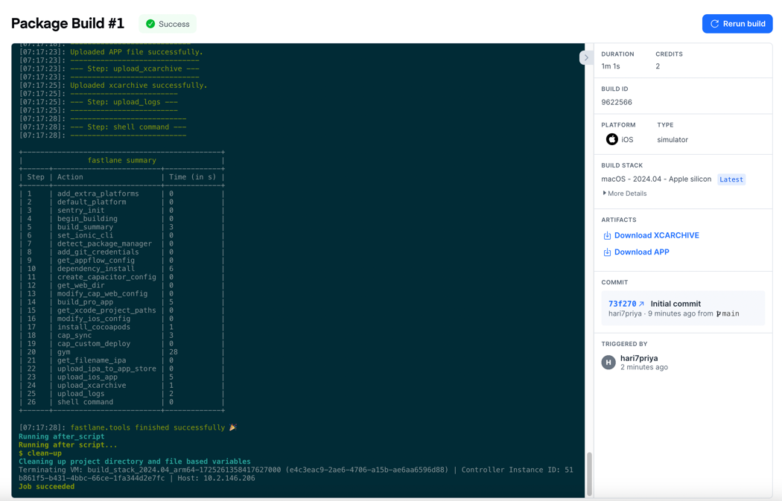

Android Build

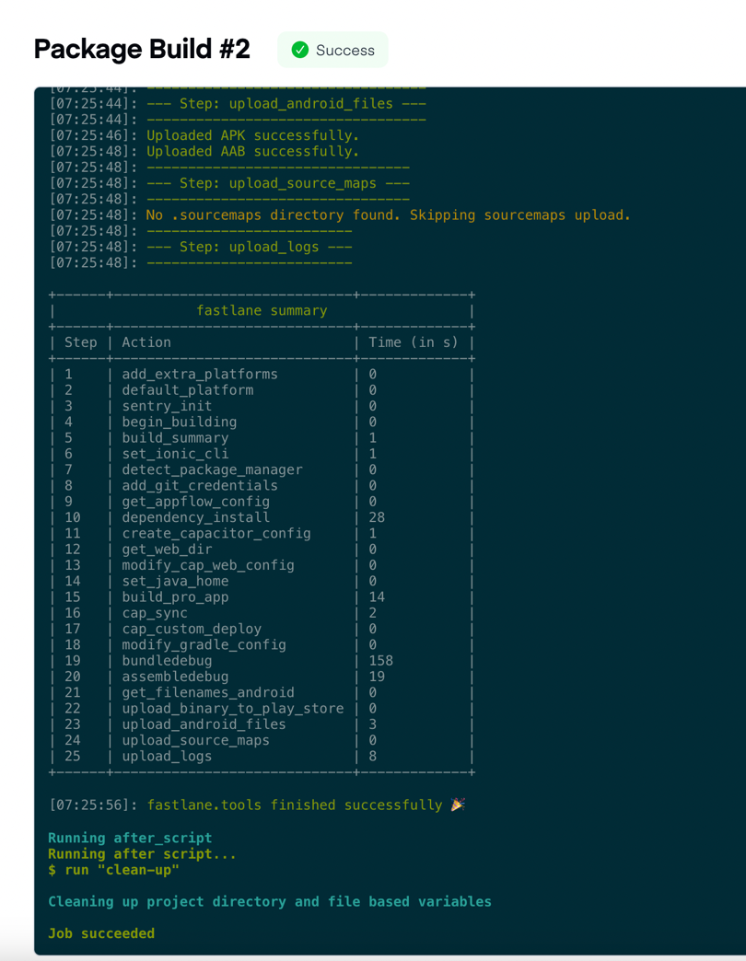

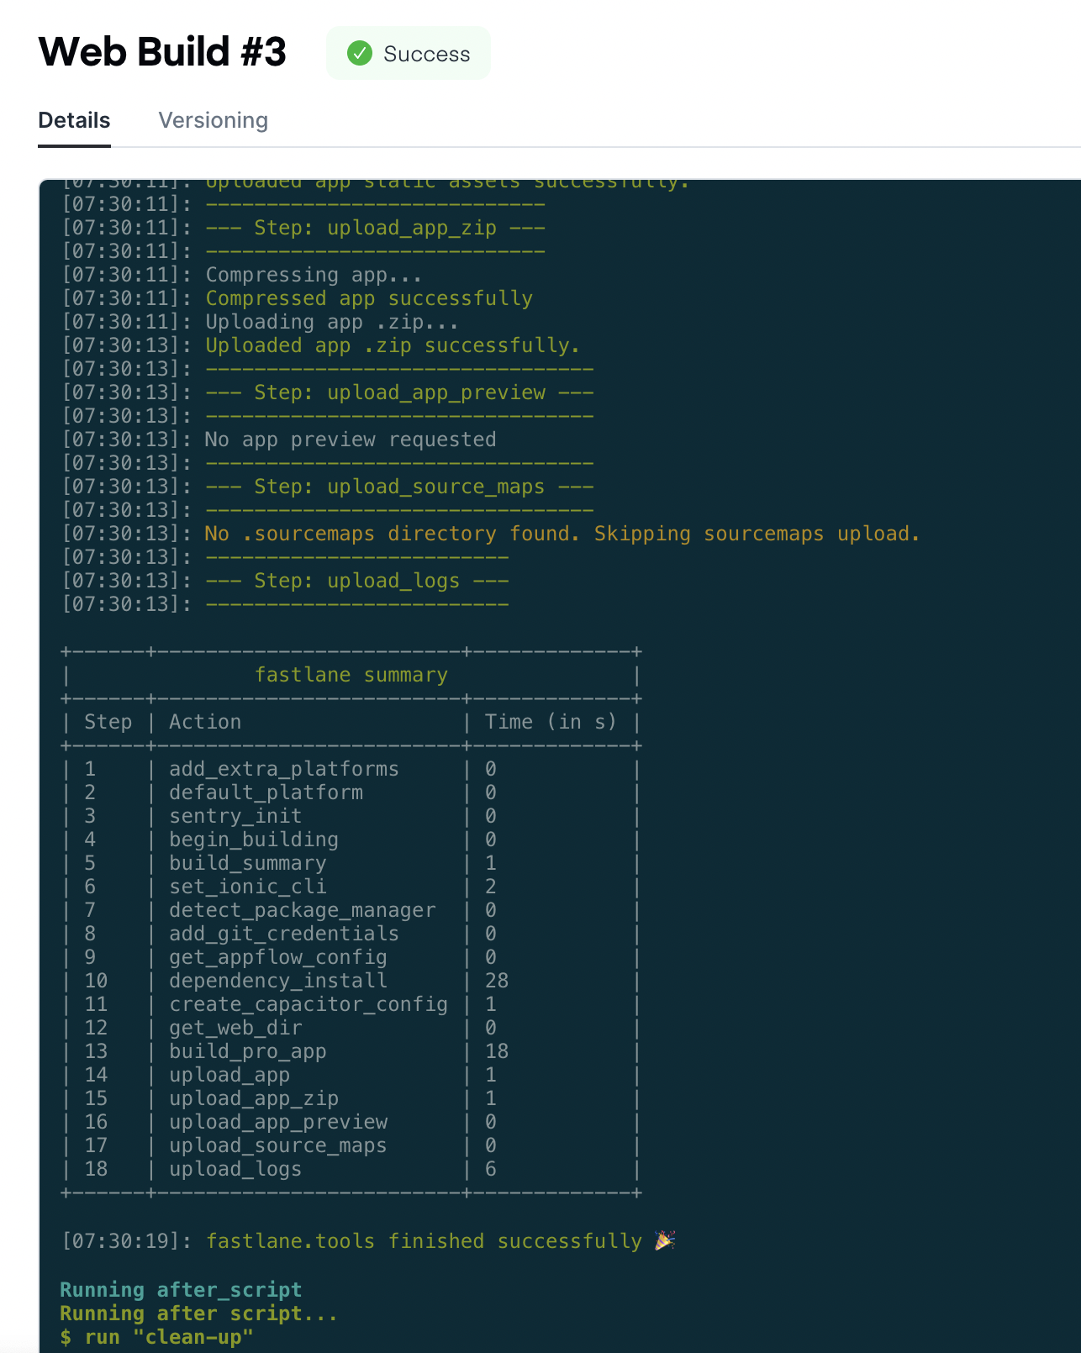

All Platform Builds***

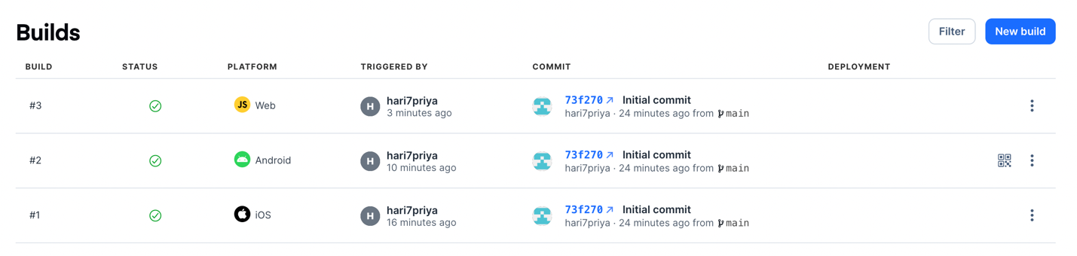

Deployments

**Android**

* Scan the QR Code or download AAP file

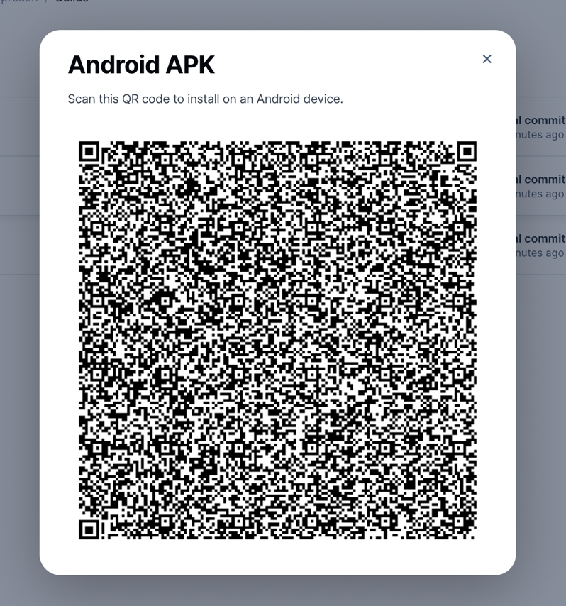

***Enable Web Preview before the build to enable previewing the app on various platforms –

**Setup Store Destinations for CICD setup**

web preview can be shared with a public URL

<https://dashboard.ionicframework.com/preview/3fdcae43/i6q0p4zjtq>

**Build and Deploy iOS and Android to the app stores**

<https://ionic.io/docs/appflow/package/intro>

**Deploy live over-the-air updates to your app**

<https://ionic.io/docs/appflow/deploy/intro>

**CICD Automation**

<https://ionic.io/docs/appflow/automation/intro>

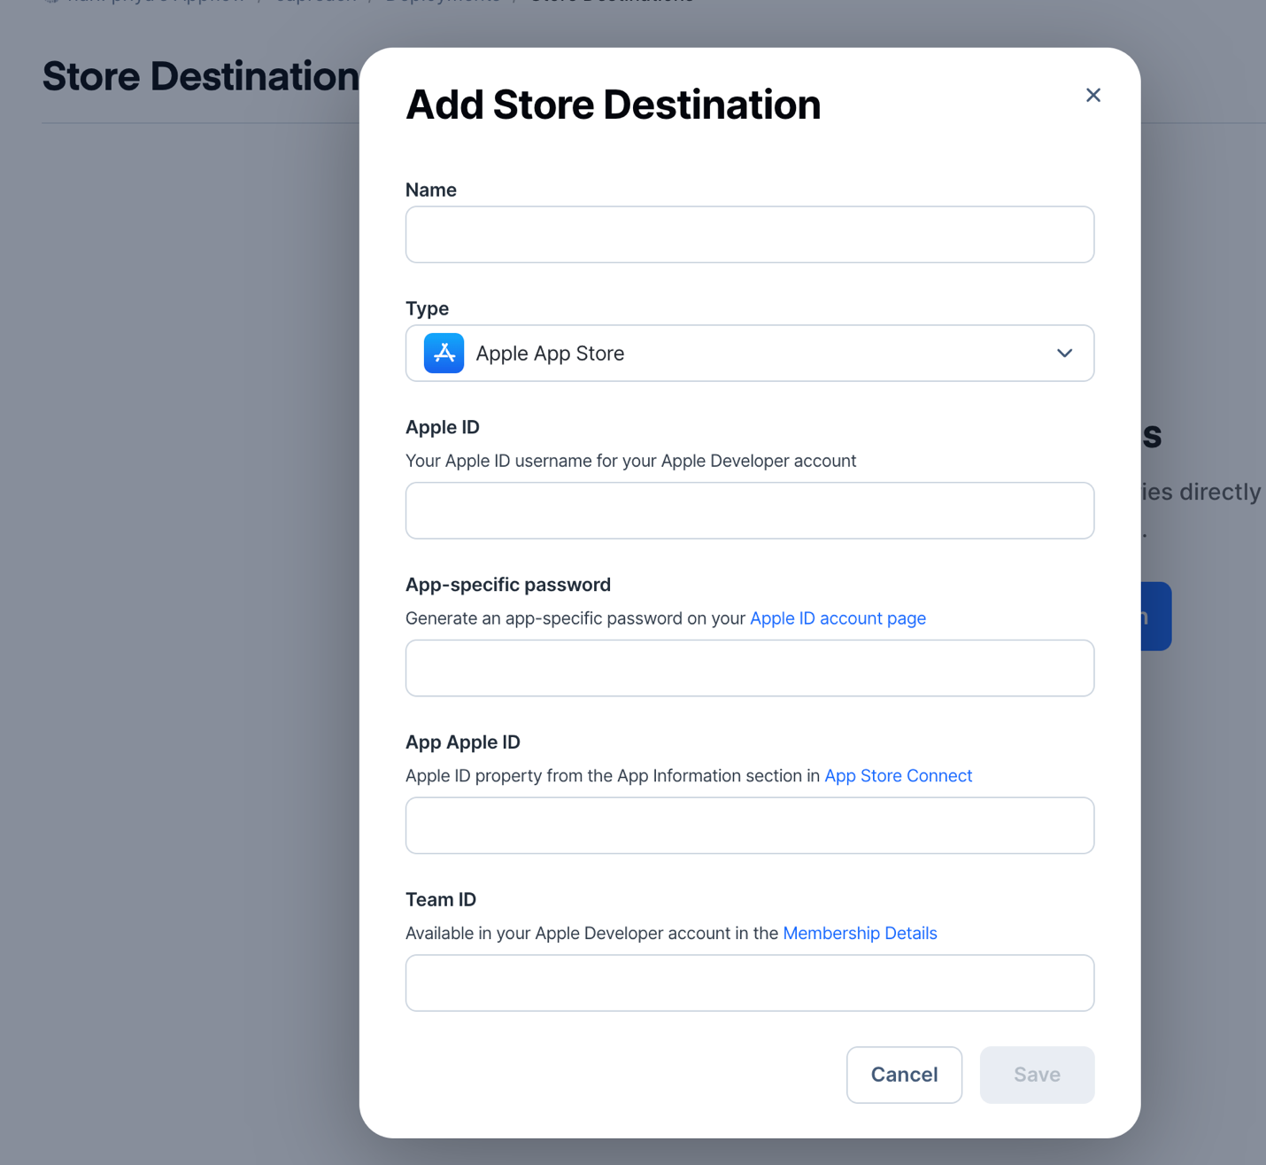

Github Repo URL - <https://github.com/hari7priya/capacitor-reach>